**IL1105: Design Thinking**

**ASSIGNMENT 1**

**Double Diamond**

Section: A

**SUBMITTED BY:**

Siddhi Nyati (2022Btech101)

**FACULTY GUIDE:**

Mr. Dhruv Saxena

JK Lakshmipat University  
Institute of Engineering & technology

**UNDERSTANDING THE DOUBLE DIAMOND MODEL**

**Introduction**

The Double Diamond Model, developed by the British Design Council, is a visual representation of the design process, structured into four distinct phases. It serves as a roadmap for innovation, encouraging both divergent and convergent thinking. By guiding teams to thoroughly explore and define problems before creating solutions, the Double Diamond ensures that the result aligns closely with user needs and business goals.

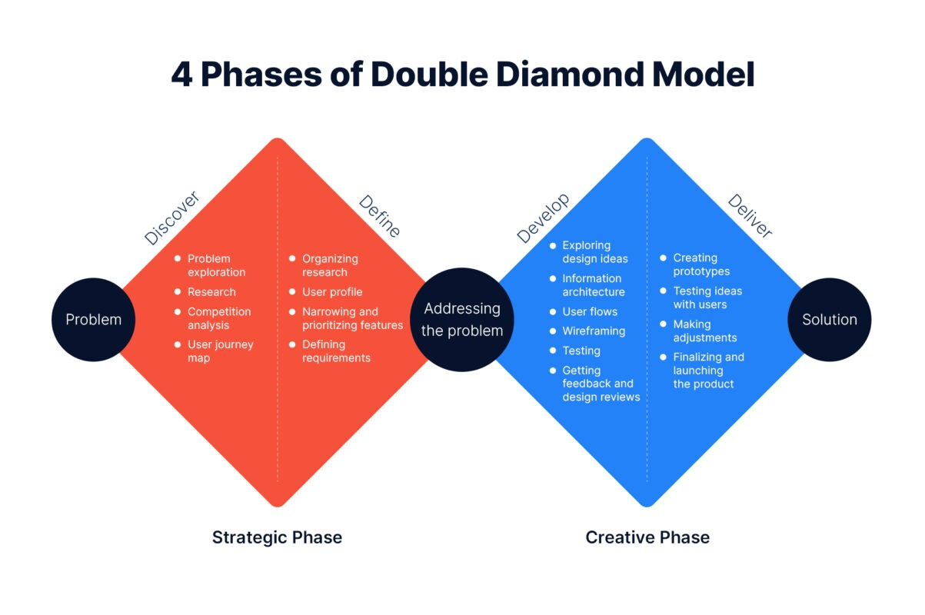

**The Four Phases of the Double Diamond Model**

1. **Discover**

The Discover phase is all about understanding the problem space. This phase encourages exploration, allowing teams to gather insights and broaden their perspective on the challenge at hand.

* Objectives: Identify and understand user needs and the broader context.
* Key Activities: User research (interviews, surveys), market research, and stakeholder interviews.
* Outcomes: A deep understanding of the problem, setting the stage for focused problem definition.

1. **Define**

In the Define phase, teams synthesize the information gathered during Discover. The goal is to clearly articulate the problem that needs solving.

* Objectives: Narrow down the insights to identify the core problem.
* Key Activities: Synthesizing data through methods like affinity diagrams, root-cause analysis, and crafting a clear problem statement.
* Outcomes: A well-defined problem statement and design brief, guiding the next steps.

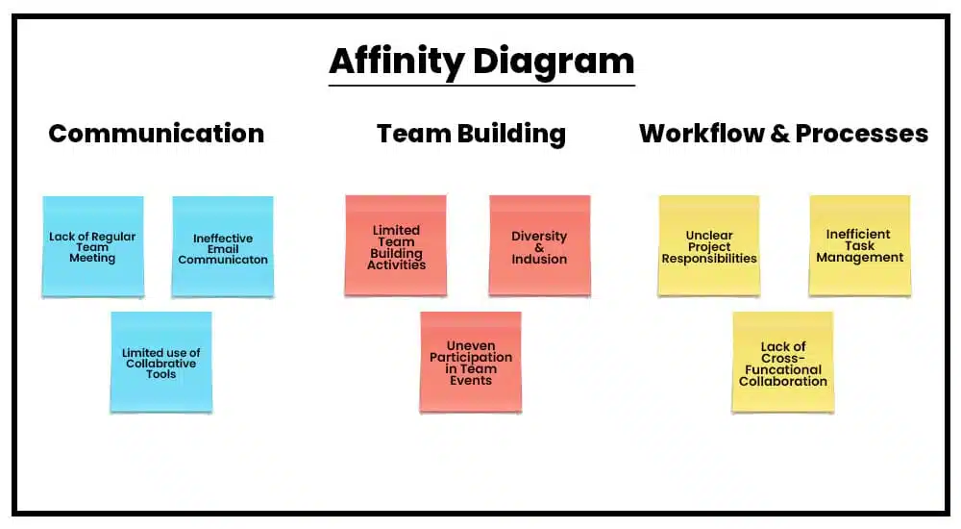

1. Develop

The Develop phase focuses on ideation and prototyping. Teams generate and iterate on potential solutions, working towards a viable design that meets the identified needs.

* Objectives: Create and test potential solutions.
* Key Activities: Brainstorming workshops, prototyping (low-fidelity designs, wireframes), and user testing.
* Outcomes: A range of possible solutions, ready for refinement and finalization.

1. Deliver

The Deliver phase is where ideas are turned into reality. Solutions are refined, developed, and launched into the market, with ongoing evaluation and iteration.

* Objectives: Finalize and implement the solution.
* Key Activities: Refining prototypes, ensuring quality through testing, and launching the solution with post-launch evaluation.
* Outcomes: A successful implementation that meets user needs and allows for continuous improvement.

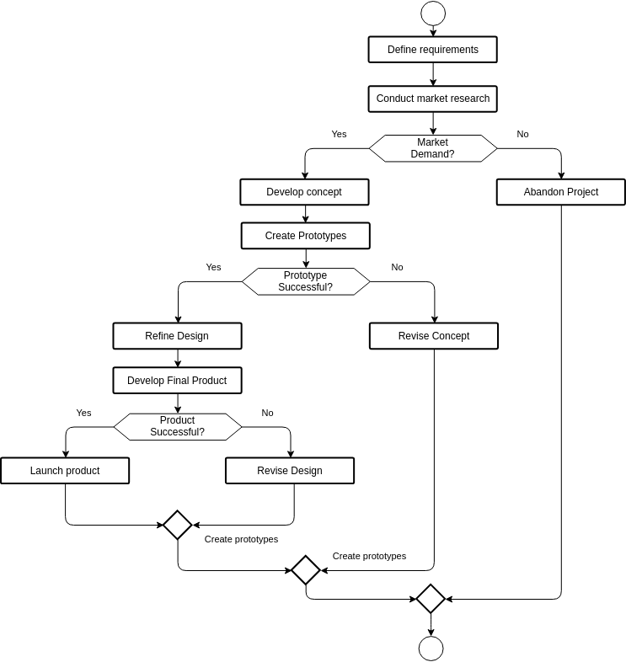

**Practical Applications and Benefits**

The Double Diamond Model is widely applicable across industries, from product design to service improvement. It provides a structured approach that encourages creativity and ensures solutions are user-centered.

**Advantages:**

* Structured Process: Helps teams navigate complex problems systematically.
* User-Centered: Keeps the focus on user needs throughout the process.
* Promotes Innovation: Encourages exploration of a wide range of ideas before converging on the best solution.

**Challenges:**

* Time-Consuming: Thorough exploration and definition phases require significant time.
* Stakeholder Management: Aligning stakeholders with different perspectives can be challenging.

Despite these challenges, the Double Diamond Model remains a powerful tool for driving effective, user-focused innovation.